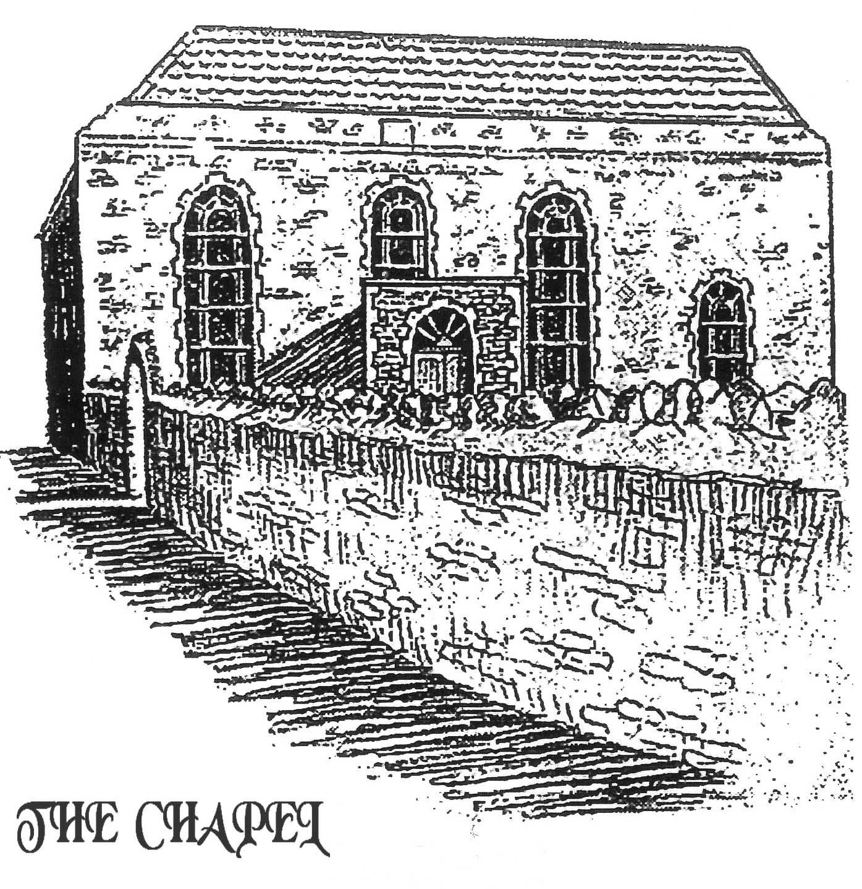
A HISTORY OF BAPTIST CHRISTIANS
&
THE BAPTIST CHURCH
HANHAM, BRISTOL
FROM 1690
The first free church was formed in Bristol in 1640 at the home, in Broad Street, of a certain Dorothy Hazzard. It later moved to the Dolphin Inn in Dolphin Street in 1643. The first Baptist Church in Bristol met in The Friars in 1650 and removed to Pithay in 1699. The Dorothy Hazzard nucleus of the first free church in Bristol became a Baptist Church in 1658 and moved into Broadmead in 1671. The earliest Hanham Baptist history is associated with the ferry near Conham Hall, and with secret preaching in the woods around Hanham by the persecuted Baptists.

The growth of Bristol's non-conformists between 1640 and 1653 was a direct threat to the sovereignty of the Church of England. Their rejection of infant baptism and of the state church caused them to be severely persecuted and when persecution became so severe the nonconformists were forced to hold secret meetings in Hanham Woods in 1658. A dedication stone previously at Hanham Mount is the earliest mention of field preachers to what was considered to be the morally darkened Forest of Kingswood.

The following quote from This Sceptred Isle - 1649 - 1660 [p 239], explains a possible reason why there were so many colliers in and around Hanham:

Until now something like 8o% of the population had worked in agriculture. The biggest industry was cloth, but the dark satanic mills were yet to come; the cloth industry was still a cottage industry. So imagine the consequences of the Civil War. The land had been ravaged and therefore so had the staple industry but by the Restoration, the second half of the seventeenth century, the new industry that took root was coal. In the sixteenth century coal was a poor man's fuel but in the first half of the 1600s there was a thirteenfold perhaps as high as a fifteenfold -increase in coal production.

Coal was not a cottage industry, it needed organized gangs of fit men to mine it. This is the beginning of private enterprise industry, industry that produced collective, structured employment.

Even in the wild surroundings where meetings were held, the religious rebels were not free from molestation, imprisonment, and often death. In 1682 the Rev George Fownes was arrested on 12th March whilst returning on horseback from Hanham; he was sent to Gloucester Prison., charged with riot, and kept there until he died on the 29th November 1685. In 1683 a lay preacher named Ford, a mercer by trade [a dealer in textile fabrics] living in the High Street, together with another preacher by the name of Mr Knight, a minister from Taunton.. were pursued at Hanham, and driven into the river near Conham Hall. They attempted to swim to safety across the Avon whilst a trooper watched unmoved. Both were overcome by the depth of water and Mr Ford was drowned. Mr Knight, although rescued by a collier never recovered and died shortly after. At one time there was also a bronze plaque on the buttress of Hanham Mount Beacon depicting these last two incidents. Sadly this has been removed from the site.

It should be explained that in crossing the river, the men would have been on the Gloucester side and beyond the jurisdiction of the Somerset police. The persecutions should have ceased upon the passing of the Act of Toleration in 1689 but in reality they continued by more subtle means.

After 1689 Hanham lost no time and the very next year, purchased a plot of land situated in the High Street on what is now the A431 main road from Bristol to Bath. On this plot of land, once an orchard, the Old Baptist Chapel was built. Despite the passing of the 1689 Act of Toleration there were many difficulties involved in its erection. An extract from Wesley and Kingswood and its Free Churches by George Evans 1911 says:

These people of God had men watching over them, like so many wolves ready to catch the lambs so soon as they were brought forth into the world. In that year [1714] they groaned under Parliament. Bolingbroke was in power, and under his auspices the Schism Bill was introduced, the object of which was to prohibit Dissenters from conducting collegiate institutions and schools, or even educating their own children. At the same time it -demanded that they should be trained by the clergy of the Established Church. The Bill was carried, loaded with reproaches, branded with the most contemptuous epitaphs. It provoked much spiteful usage. Yet our brave forefathers laid stone by stone until the chapel was completed

Using local stone and timber, the building was completed in 1714 and was the first and only local place of worship until after 1739. The long windows, which replaced the original small, square windows in 1868, finished in a graceful arch and an inner, parallel line of blue glass emphasised their shape. A sizeable porch gave entry to the main building. Set into the outside wall was a solid foot scraper [hopefully removing a considerable amount of the mud collected on the boots of those crossing the fields]. The pulpit was central and set behind a baptistry in the floor of the building. Outside there was a stable and hitch-rail where visiting preachers left their horse.

In 1721 the churchyard was opened. It contains a memorial stone to Mary Perryman who, at the age of 7 years, died on 19th February 1783. Her father, a stonemason,, was working in the quarry in Longwell Green [the present site of Comet, B & Q, Asda, etc] getting large slabs of stone which he carved into head stones. One day, having got one large slab, he rested it against his horse and cart and went off to get another. His daughter, Mary, who had gone to the quarry with him, was playing nearby, when something startled the horse which subsequently bolted. The slab stone fell upon her and crushed her to death. The stone that had killed Mary became her gravestone. There is also a gravestone in memory of two victims of cholera. The graveyard was closed in 1935.

Although the Hanham Baptists had their own chapel in 1714, there was still no church for the colliers and other forest squatters in 1738 when a Church of England clergyman, Mr Morgan, felt compelled to preach in the, open outside their hovels. This early field preacher is over-shadowed by the more dynamic personalities who came to Hanham Mount early the following year, namely George Whitfield and John Wesley, who began their open air preaching in 1739, Whitfield on Saturday, 17 th February and Wesley on 8th April of that year.

Although both ordained ministers of the Church of England, the nearest church to Hanham was at Bitton, and the unorthodox practice of preaching in the fields was, therefore, considered to be a local necessity. Whitefield's journal of 4th March 1739 definitely mentions that he hastened to Hanham Mount three miles from the City, where the colliers lived together.

In John Wesley's journal we read:

Saturday March 31" 1739

In the evening I reached Bristol, and met Mr Whitefield there. I could scarcely reconcile myself at first to this strange way of preaching in the fields, of which he set me an example on Sunday: having been all my life (til very lately) so tenacious of every point relating to decency and order, that I should have thought the saving of souls almost a sin, if it had not been done in church.

But just a week later, on Sunday 8 th April 1739, he records: I preached to about fifteen hundred on the top of Hanham Mount in Kingswood.

Travelling around the countryside was still dangerous in 1777. Another entry in John Wesley's journal reads:

Tuesday December 16 1777

I paid a short visit to Bristol; preached in the evening and morning following, Wednesday 17 ... Just at this time there was a combination among many of the post-chaise drivers on the Bath road, especially those that drove at night, to deliver their passengers into each other's hands. One driver stopped at the spot they had appointed, where another waited to attack the chaise. In consequence of this, many were robbed; but I had a good protector still. I have travelled all roads, by day and by night, for these forty years, and never was interrupted yet.

Whitfield and Wesley remained ordained ministers of the Church of England, but they offended by preaching in the parish of Bitton although several miles from Bitton Church. The Bishops eventually closed the Bristol pulpits to them. Church or no church, wrote John Wesley to his brother Charles, we must attend to the saving of souls.

Hanham Mount, with its pulpit and beacon, is a well-known landmark and a lasting memorial to the early field preachers. Looking over the extensive panorama of Somerset, the Avon Valley and Hanham woods, John Wesley's words: “I look upon all the world as my parish” echo the voices of the Baptist preachers of 1658.

In the early years the Baptist congregation in Pithay was closely associated with the congregation in Hanham and Keynsham, and provided preachers who travelled out over the appalling roads to preach on Sundays. In 1802 the Rev John Sharpe was inducted as Pastor of Pithay and it is recorded that his labours were remarkably successful especially in the country at Hanham and Keynsham. [The Keynsham Baptists, similarly persecuted, had met in each other's homes until 1784, when they purchased a barn off Danes Lane, now Charlton Road. The present site in Keynsham High Street, was purchased in 1802.] This is endorsed by another report which states that upon the opening of the enlarged building at Hanham, he [John Sharpe] exerted himself much in obtaining subscriptions for defraying the expense of the building and the whole was soon paid.

Mr Sharpe died in 1805 and, after an interregnum of two years, Mr Roberts from Brixham agreed to come but only on the understanding that he would not be responsible for Hanham and Keynsham. The outcome was that in 1807 the Hanham and Keynsham churches became independent, subsequently appointing a joint pastor but their own deacons. On 28th October 1807, Mr John Hutchings was appointed Pastor and it was agreed with him that he should be paid a minimum of £60 per annum and that ‘some one or other of the members of the church should provide him with a horse and cart to convey him from Keynsham to Hanham on every Lord"s Day to preach in the afternoon’. Mr Hutchings resigned on 13 th February 1813. His letter of resignation was, in effect, a carbon copy of the earlier situation at The Pithay. The Hanham Church was almost as far distant from Keynsham as the two churches were from Pithay, and the exertions of looking after both churches was having an adverse effect on his health.

In 1814 the Rev Thomas Ayres became joint pastor of the two churches, remaining at Keynsham for thirty-eight years, until early 1852.

Both churches had crises along the way. In 1817 at Hanham, their only remaining deacon became incapable because of old age. The other two deacons, John Britton and John Jarrett, had been excluded in 1811 for non-attendance. Three brethren were elected to fill the vacancies created, namely Job Fudge, Daniel Short and John Ody. Fudge was later excluded for selling beer on the Sabbath and Short for non-attendance. Ody lived long enough to be transferred to the newly formed Hanham Church in 1850. The story at Keynsham was little better for Brother Wise was requested to resign as a deacon because he was disrespectable and misrepresented Brother Edwards, a fellow deacon. However, the two churches survived these difficulties, but during the mid 1840s the health of the pastor began to deteriorate and the Hanham Baptists were becoming restless. They sent a letter to Keynsham which read:

For a long time past every prospect appears to be given up respecting our dear Pastor ever being so far restored as to labour amongst us. At our last Church Meeting held on July 16th it was our unanimous conclusion that a separation between our Churches ought to take place.

They went on to point out that over the previous thirty years no less than eight churches and chapels of various denominations had been erected in the parish, each of which had morning and evening services where they had to be content with an afternoon service. The church at Keynsham readily agreed and less than two months later, on 6 th September 1850, thirty-five persons were dismissed to form a separate fellowship at Hanham. Sixty-five members remained at Keynsham.

Following the separation, Hanham called its first pastor in 1851, the Rev John Newth who was succeeded in 1859 by Mr Thomas Bowbeer and Mr H Medway, who were co-pastors after the Order of the Itinerant Society.

The church continued to meet in the Old Chapel.

The history of the Old Chapel:

1690 Site purchased following the Act of Toleration 1689.

1714 The Meeting House [Old Baptist Chapel] was erected.

1721 The graveyard opened.

1802 The meeting House was enlarged with a brick wall being constructed
at the east end and inside a large platform was built behind the
pulpit. At the west end of the chapel a second floor, almost like a
balcony was built. It could be screened off.

1825 Fourteen feet was added to the front of the graveyard by purchase
from the roadside common.
1868 Small square windows were replaced by long ones.

1871 Land for lean-to vestries was given by Mr Palmer, JP.

1872 Lean-to buildings were added.

1907 After the completion of the Church [the New Chapel] in 1907 the
building was used mainly as a meeting room for the Sunday School,
mid-week activities and social events, such as Harvest Suppers.

1924 Lean-to building for kitchen and toilets were added. One lean-to
building was used as a men's bible class base on Sundays.

1924 The Old Chapel was entirely renovated by voluntary labour, the cost
of the materials being met by gifts from members of the church.

1935 The graveyard was closed.

Due to blackout regulations during the years of the second world war, the Old Chapel came back into regular use as the sanctuary. One of the lean-to rooms became a small shooting range for the Home Guard.

1958 The Old Chapel was renovated and used for worship once more
during the re-building of the Church following a serious fire.

1971 The Old Chapel was demolished.

Church records give little or no information until the call of the Rev P Michael in 1896. Under his leadership plans were prepared for a new church building to be built on a plot of land situated across the alleyway from the Old Baptist Chapel. The estimated cost was £3,000. The Baptist Union contributed £500 to the cost and by 1905 the congregation had raised another £500, [the final cost of the building was £2,215], leaving an outstanding debt of around £1,200. The New Chapel was opened in 1907 during the pastorate of the Rev S J Ford, who came to Hanham in 1921, and the final debt was cleared in 1922. [The Rev Michael had left Hanham to become forces chaplain during the First World War.] The school hall at the rear of the Church was built by voluntary labour during 1935. [Lay a brick for sixpence.]

On Tuesday 4th March 1958 a mystery fire destroyed the organ, choir stalls and two vestries. [The organ had been purchased in 1950 from Lady Smyth's estate, Ashton Court, at a cost of £1,500.] Firemen fought through choking smoke to attack the fire, which they initially controlled, but the blaze broke out again in the roof. Thanks to the generous time and effort put in by Ambrose Cottell and Jack Lampard, the Old Chapel was completely redecorated, and the women from the Church supplied curtains, and rugs for the floor; the existing floor was wooden and very uneven. The Old Chapel was transformed and become the place of worship during the reconstruction period. And what"s new? The Church had to take out third party insurance in the event of anyone failing on the wet, slippery flag stones and gravestones leading to the chapel door. The cost of the rebuilding and reconstruction of the church following the fire was in the region of £10,000. The Church was reopened on 19th September 1959, eighteen months after the fire.
In 1971, towards the end of the pastorate of Rev Peter Crowhurst, the Old Baptist Chapel was demolished, mainly because of the poor condition of the roof timbers. A modern building which became the New Hall was built and opened in 1972. A wooden beam taken from the original Old Baptist Chapel has been built into one of the walls.

The inscription reads:

THE OLDEST PLACE OF WORSHIP IN KINGSWOOD & HANHAM AMONGST LOCAL PLACES LICENSED FOR WORSHIP UNDER THE TOLERATION ACT [WILLIAM & MARY 1689] WAS SAMUEL HARVEYS HOUSE HANHAM FOR BAPTIST WORSHIP LICENSED EASTER 1709

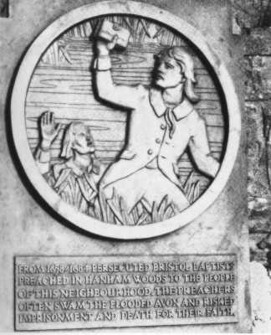
The plaque at Hanham Mount honouring the Baptist field preachers. The plaque reads: “From 1655 to 1684, persecuted Bristol Baptists preached in Hanham Woods to the people of this neighbourhood. The preachers often swam the flooded Avon and risked imprisonment and death for their faith.
The Old Baptist Chapel
Mary Perryman's gravestone. The inscription reads: “This is the stone that spilt my precious blood: Mary Perryman, the daughter of Martha and Jacob Perryman. Died February 19th 1783. Aged 7 years.

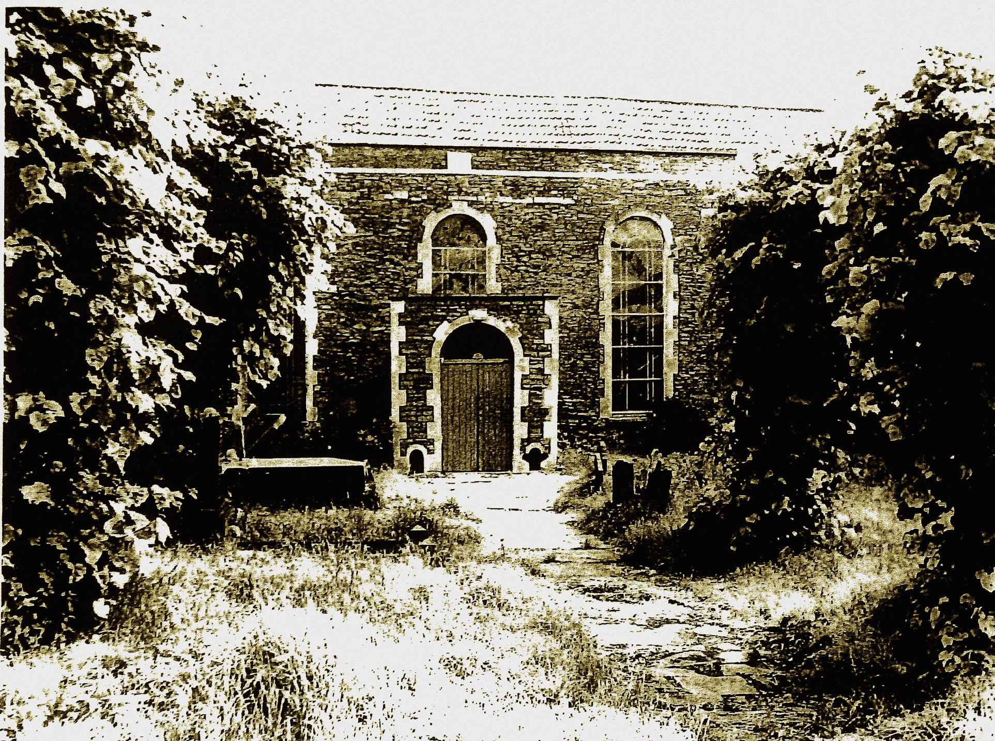

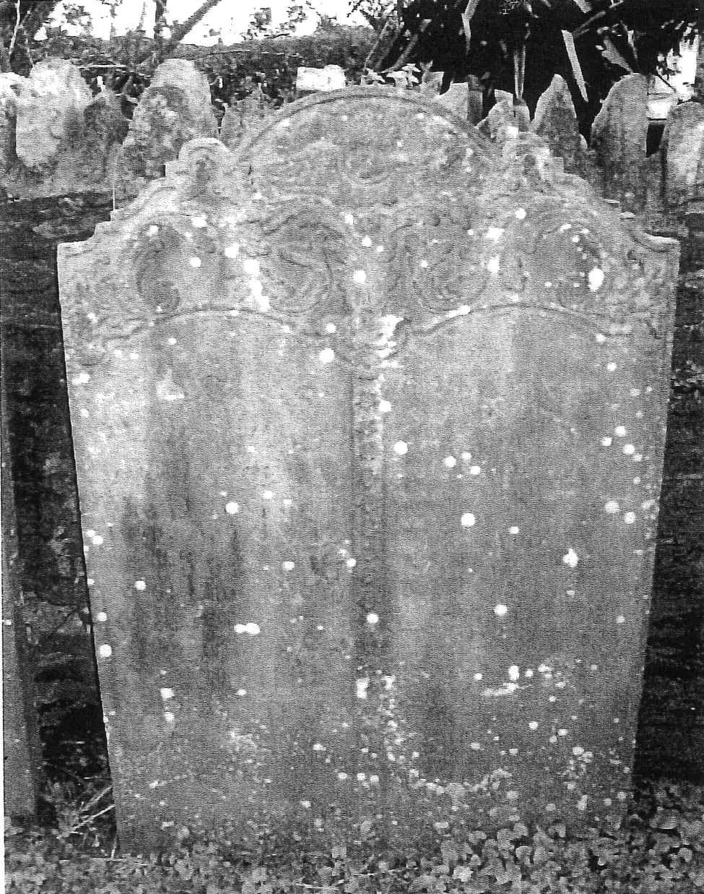

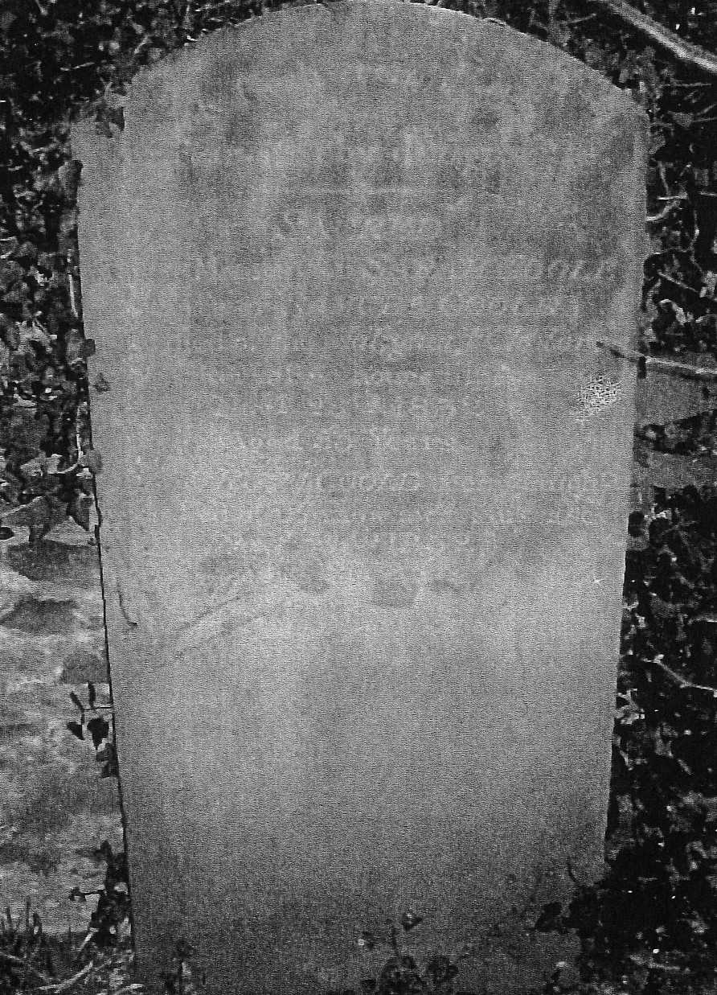
COOLE GRAVESTONE, IT READS:
“Sacred to the memory of Sarah Coole wife of Samuel Coole who died of the Malignant Cholera after a few hours illness, November 28th 1832 aged 55 years. Also of Ruth Coole their daughter who died of the same awful disease, November 24th 1832 aged 12 years.

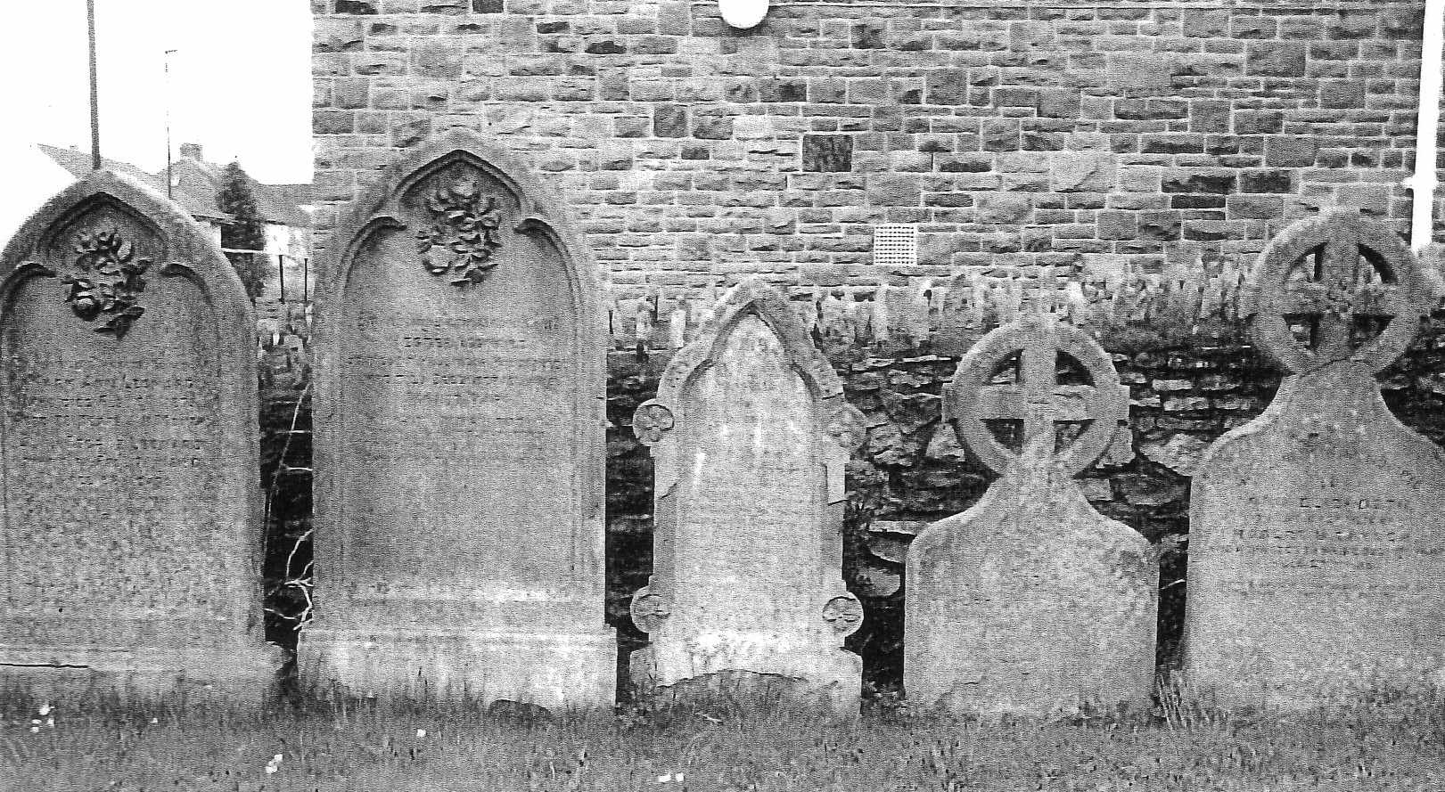
Gravestones moved to the sides of the graveyard in the mid-sixties

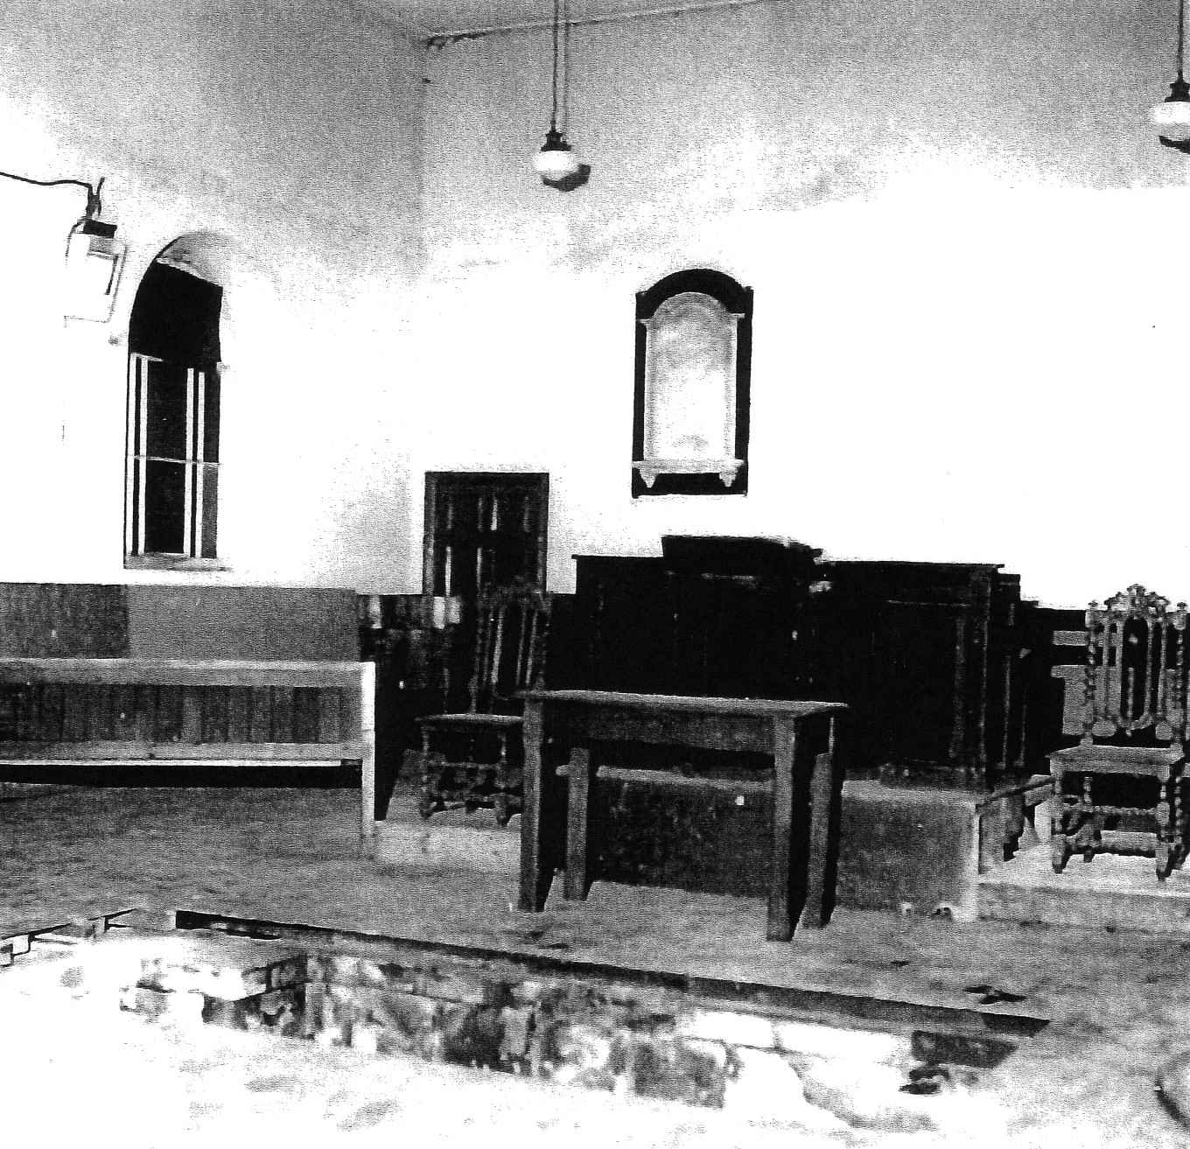
Old Chapel showing pulpit and baptistry

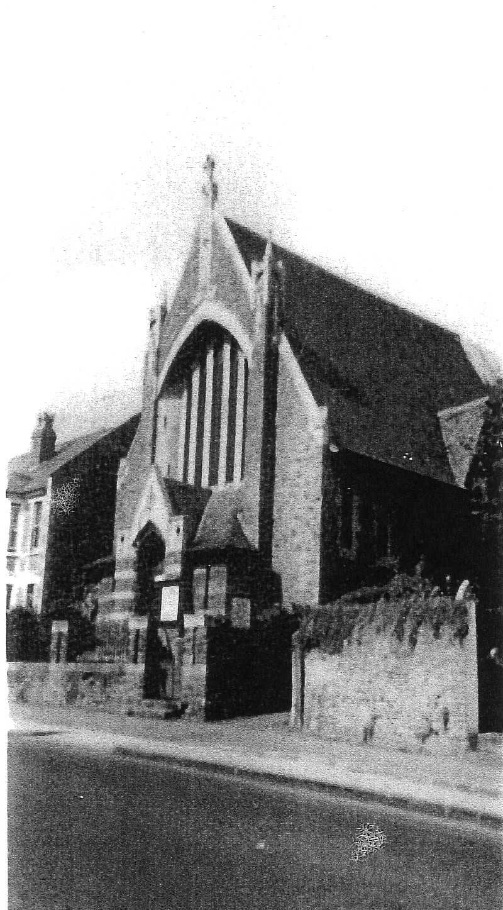
Hanham Baptist Church before the fire of 1958.

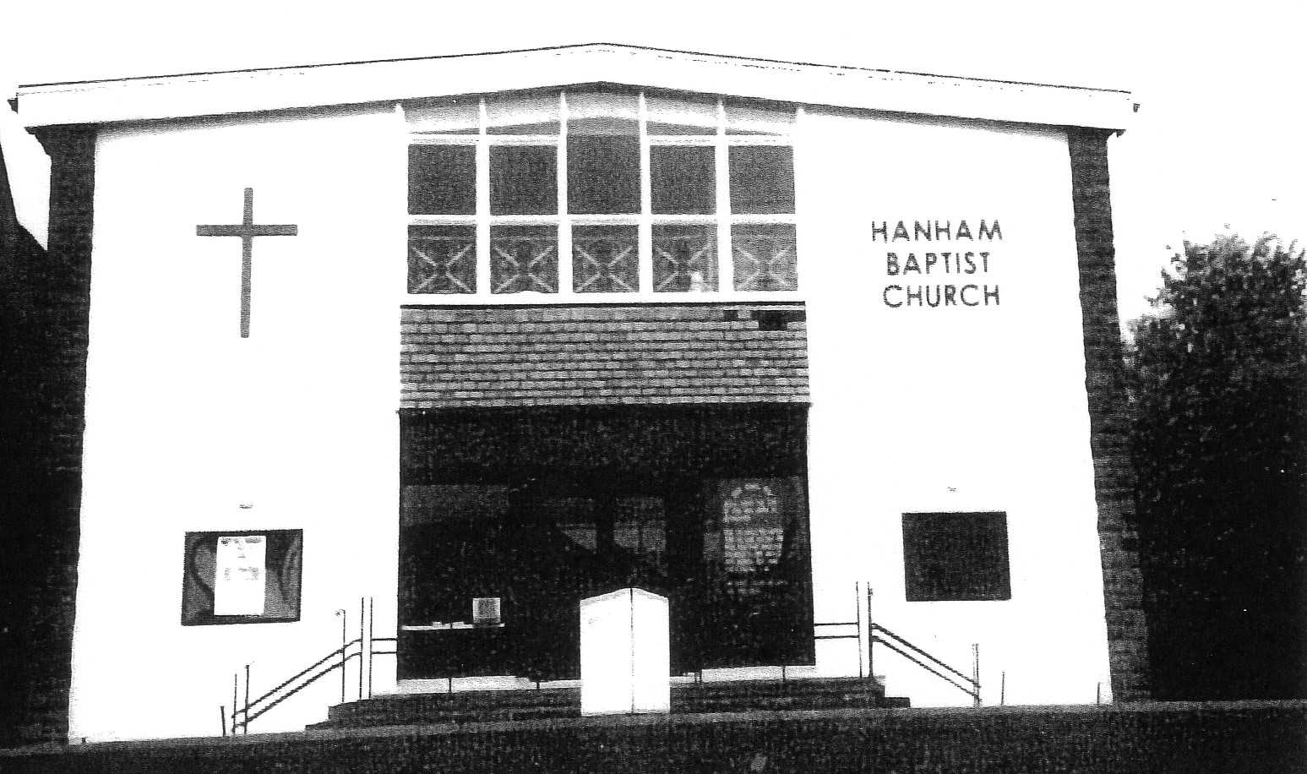
The church after it was rebuilt following the fire

The new hall built on the site of the old chapel and opened in 1972.



